**Assignment 2: Introduction to Git & GitHub**

Part 1: Create a Local Repository

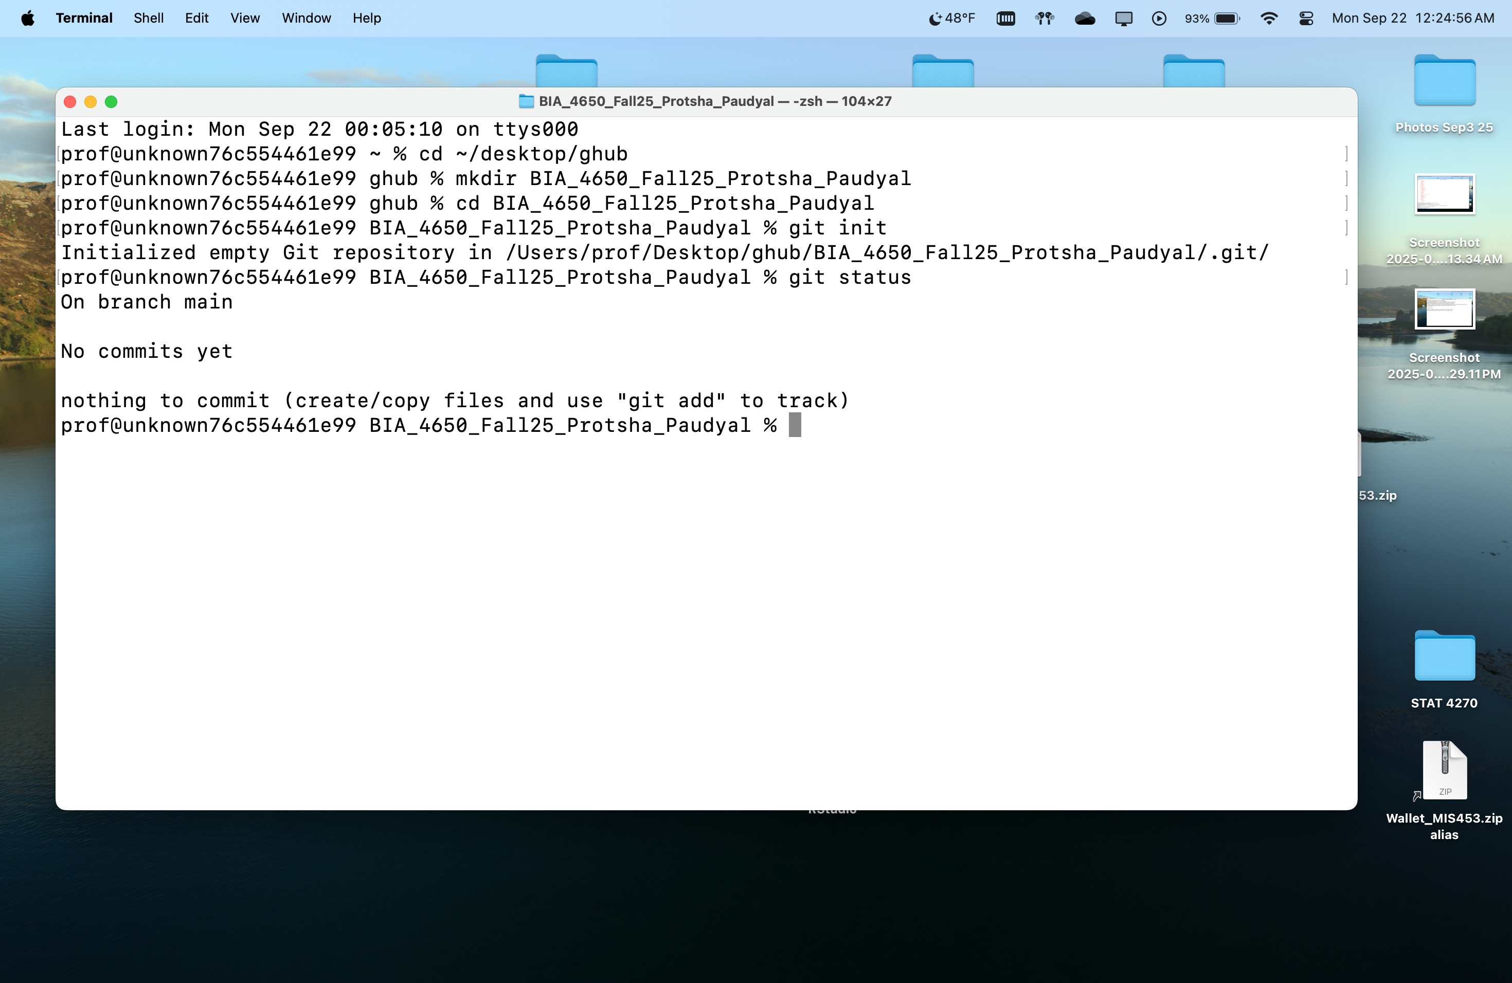

Part 2: Add Assignment Files

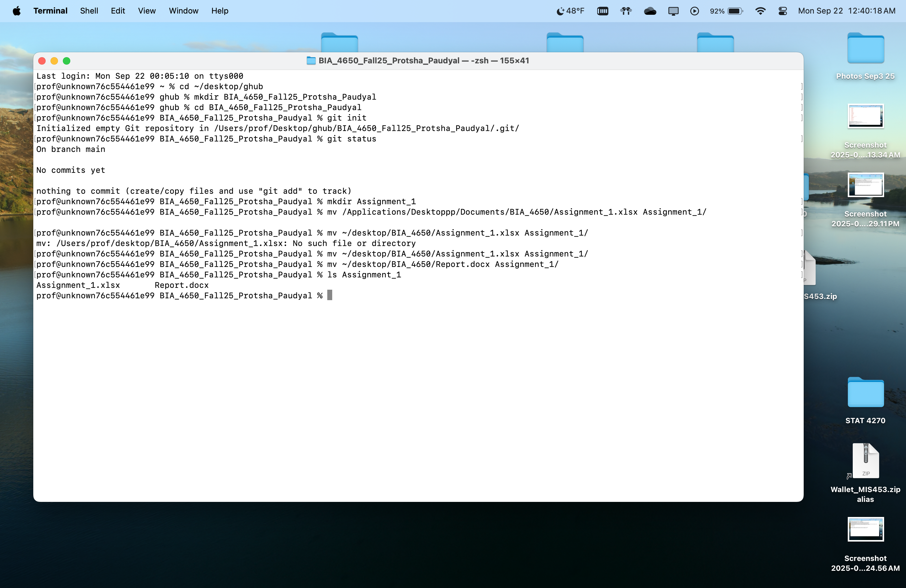

Part 3: Stage and Commit

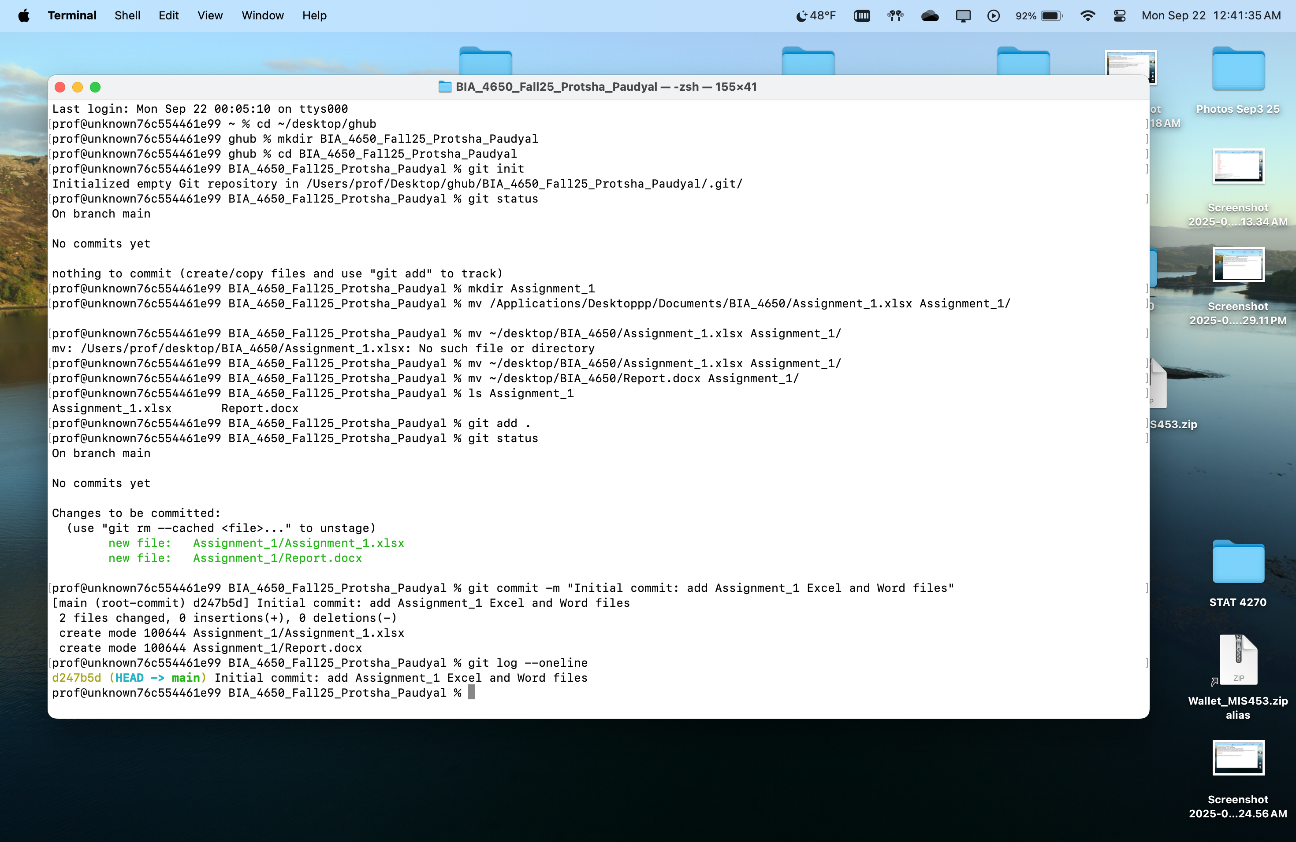

Part 4: Create a GitHub Repository and Connect Remote

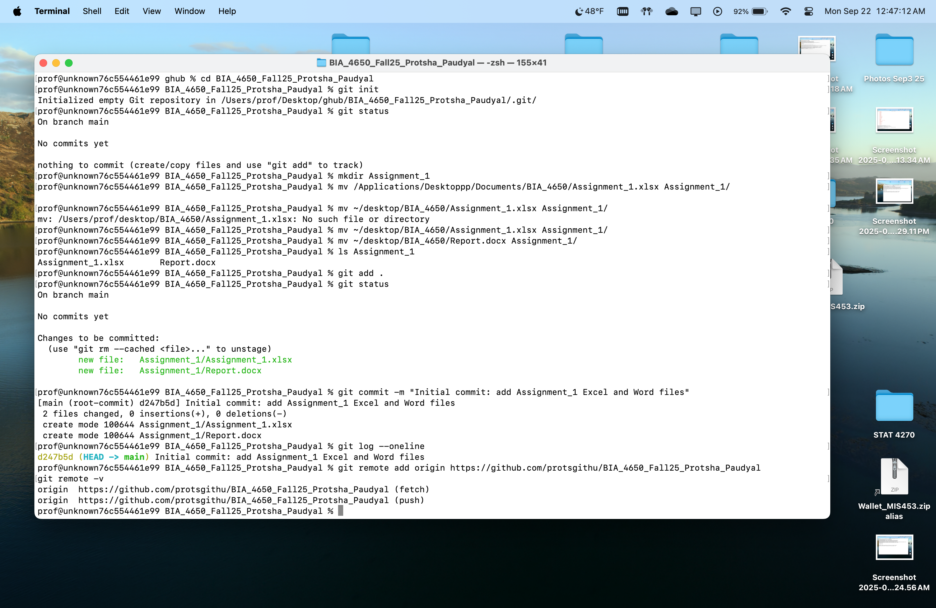

Part 7: Authenticate and Push

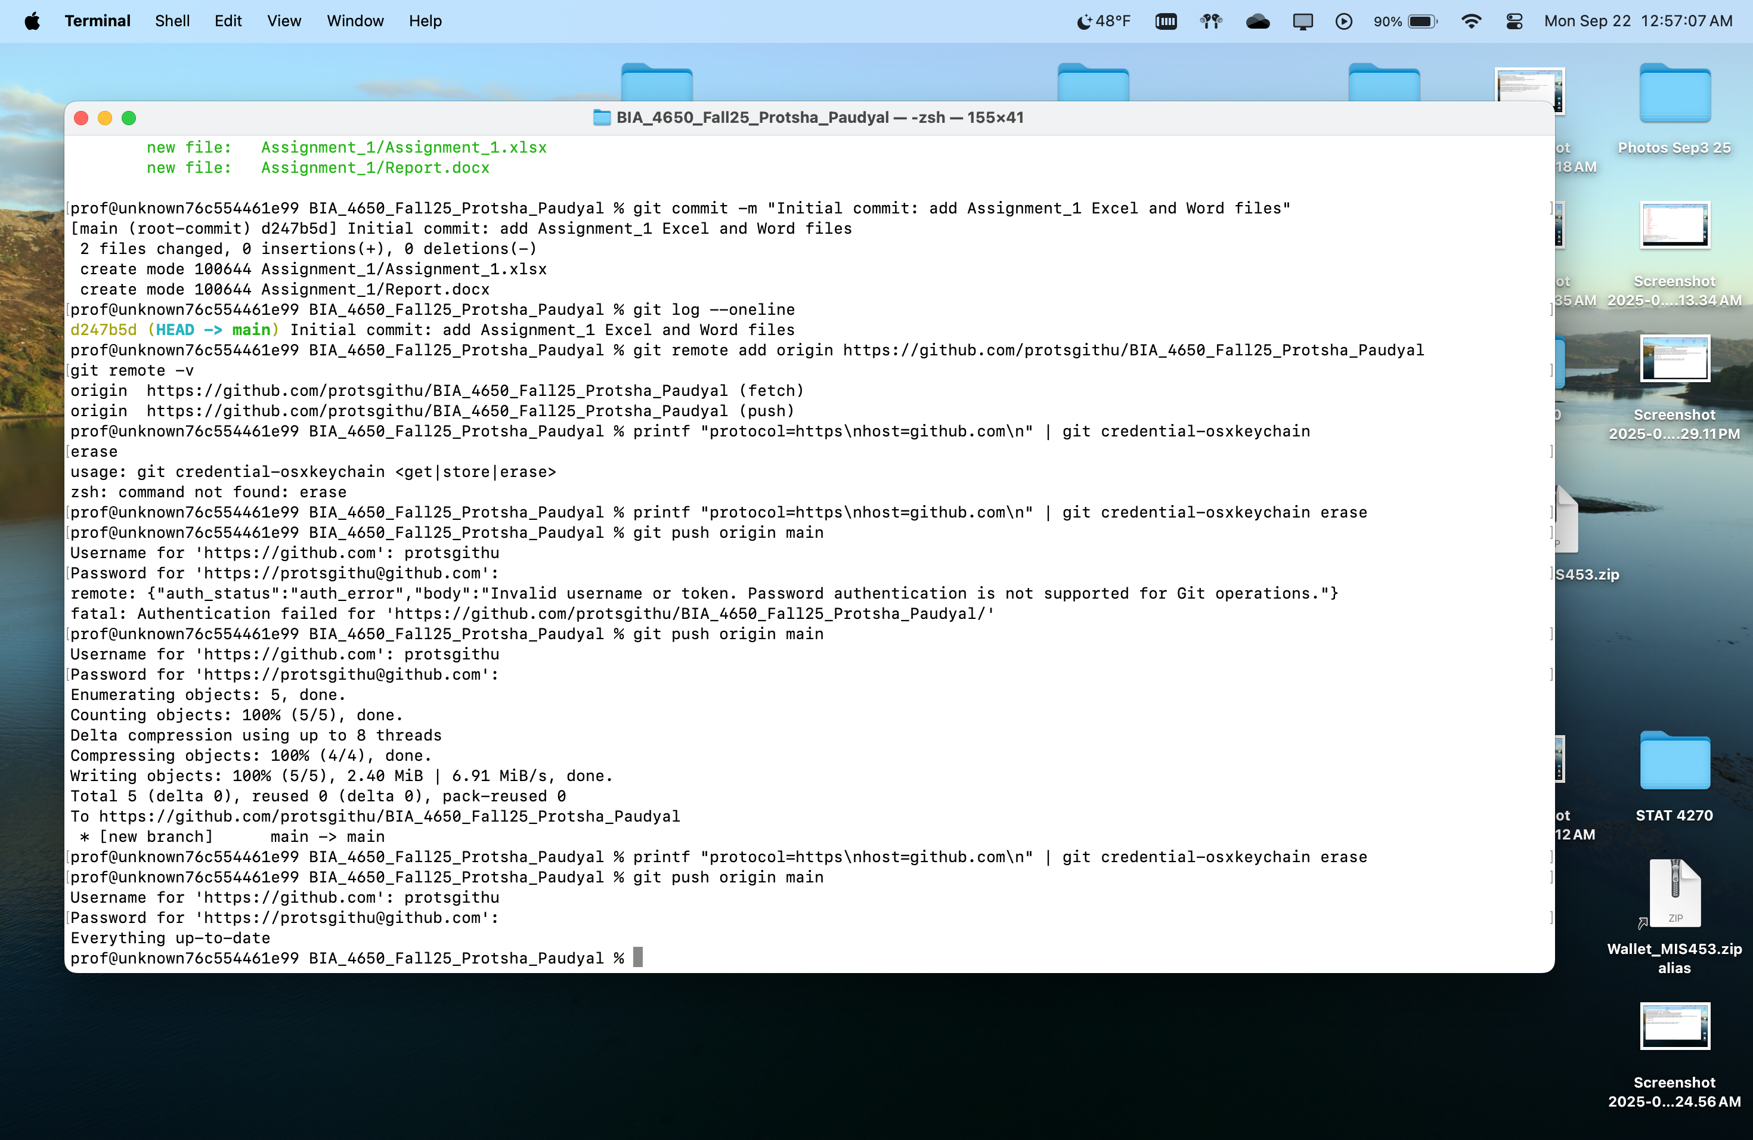

Part 8: Verify on GitHub

